Downloads = My Certificates
Address And Company Details: And = and
Notes and Reference is not mandatory in payments. Remove the checks
When signed in: Account = My Account
When signed in. Join online today = Logout
Remove auto fill option in repeat email
Upload the new logo
Page titles should be the name of the tabs
Text: Select company size by number of employees
Text: Select your rank in the company
Payment = My Payments
Member: On edit it should allow edit in the grid. Should not take to the application form.
Text Area above payments
When a member click enrol, a confirmation check should apply, are you sure you want to enrol for this course? If clicked yes, status should change to enrolment requested.
In application form: Font colour should be dark black
When a course is enrolled by admin, start and completion date is coming automatically
A confirmation link has been sent to your given email address. Please follow the instructions in the email to confirm your email address.
You are signing up to join Organisation of Certified Risk Managers. Confirm your email and you will be ready to join.

Confirm Email

If you have received this email by error, please let us know on membership@ocrmglobal.com
A new password has been sent to your email address.
Dear Name,

This message is in reply to a request to resend your password.
Your Password is:
Kind regards
OCRM IT Help Desk
Cannot enter a course status. Cannot view course status in edit
Once a data is used somewhere, should not be delete able. i.e. a course status is used against a user, should have option to be active or inactive rather than delete. A Course has been used . Should not be delete able.
Select your rank in the company = Select your seniority level in the company
In payment, invoice should be downloaded rather than opening in the same browser
There should be a balance on payment section ;

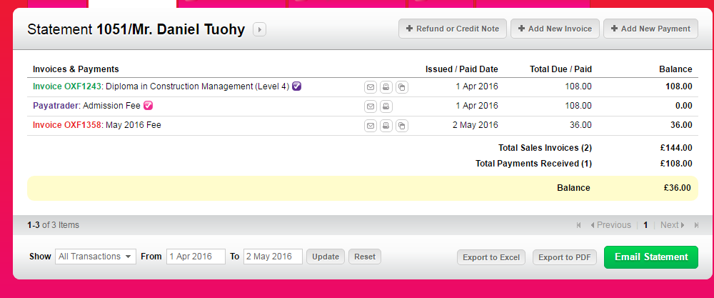

There should not be invoice number in payment section grid of learners.
Invoice date = Date
Description should come first
When we invoice, it appear as credit in member’s area.
In payments, there should not be any download able documents for payments and credit note
Grid headings area colur should be blue.
Tabs problem in admin section. Which ever section is opened, it closes and cms section opens automatically.
Place check on Enrol and undo on my courses section
In assignments: Upload file = Upload assignment
When an assignment is submitted, user should remain on the same section. It is taking main starting area of my courses
When an assignment is uploaded, status should be Submitted. When result is uploaded
By default status of a module and chapter should be in progress.
In my courses: Module Title = Authorised modules
Create emails inbox section
There should be a , after name in the email
On user level, there should be highlight of any new email
Occupation and employment status fields should be in company details
On Enrolment requests grid, give a link under course name which should directly take to that’s users courses section
Enrolments requests filter: add+ Country + Course + Status and a search option Paging should be applied with option to export in excel
When a user submits the full application, default status should be application submitted.
In members grid: Membership type = Application type
There should be a membership type (PDV) field in general details
In admin: Memebrs tab = New Applications
In mebers: Add filter. Status, Application type, Country and a search tab to search by email
In courses, course start date should be the course enrolment date. Start date = Enrolment Date it should appear automatically.
There should be module authorisation date
There should be module completion date
There should be chapter completion date
There should be assignment submission, Result date and completion date
Here is an error in assignment section.
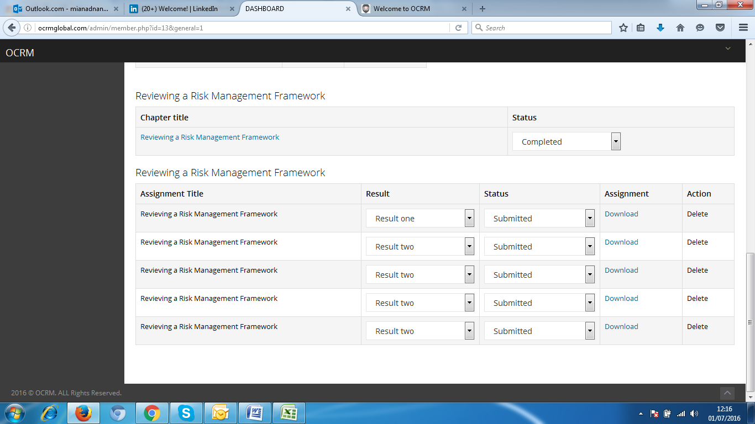

Add industry selection option in company details: Option will be search, display and select.
Industry
- Accounting
- Airlines/Aviation
- Alternative Dispute Resolution
- Alternative Medicine
- Animation
- Apparel & Fashion
- Architecture & Planning
- Arts and Crafts
- Automotive
- Aviation & Aerospace
- Banking
- Biotechnology
- Broadcast Media
- Building Materials
- Business Supplies and Equipment
- Capital Markets
- Chemicals
- Civic & Social Organization
- Civil Engineering
- Commercial Real Estate
- Computer & Network Security
- Computer Games
- Computer Hardware
- Computer Networking
- Computer Software
- Construction
- Consumer Electronics
- Consumer Goods
- Consumer Services
- Cosmetics
- Dairy
- Defense & Space
- Design
- E-Learning
- Education Management
- Electrical/Electronic Manufacturing
- Entertainment
- Environmental Services
- Events Services
- Executive Office
- Facilities Services
- Farming
- Financial Services
- Fine Art
- Fishery
- Food & Beverages
- Food Production
- Fund-Raising
- Furniture
- Gambling & Casinos
- Glass, Ceramics & Concrete
- Government Administration
- Government Relations
- Graphic Design
- Health, Wellness and Fitness
- Higher Education
- Hospital & Health Care
- Hospitality
- Human Resources
- Import and Export
- Individual & Family Services
- Industrial Automation
- Information Services
- Information Technology and Services
- Insurance
- International Affairs
- International Trade and Development
- Internet
- Investment Banking
- Investment Management
- Judiciary
- Law Enforcement
- Law Practice
- Legal Services
- Legislative Office
- Leisure, Travel & Tourism
- Libraries
- Logistics and Supply Chain
- Luxury Goods & Jewelry
- Machinery
- Management Consulting
- Maritime
- Market Research
- Marketing and Advertising
- Mechanical or Industrial Engineering
- Media Production
- Medical Devices
- Medical Practice
- Mental Health Care
- Military
- Mining & Metals
- Motion Pictures and Film
- Museums and Institutions
- Music
- Nanotechnology
- Newspapers
- Nonprofit Organization Management
- Oil & Energy
- Online Media
- Outsourcing/Offshoring
- Package/Freight Delivery
- Packaging and Containers
- Paper & Forest Products
- Performing Arts
- Pharmaceuticals
- Philanthropy
- Photography
- Plastics
- Political Organization
- Primary/Secondary Education
- Printing
- Professional Training & Coaching
- Program Development
- Public Policy
- Public Relations and Communications
- Public Safety
- Publishing
- Railroad Manufacture
- Ranching
- Real Estate
- Recreational Facilities and Services
- Religious Institutions
- Renewables & Environment
- Research
- Restaurants
- Retail
- Security and Investigations
- Semiconductors
- Shipbuilding
- Sporting Goods
- Sports
- Staffing and Recruiting
- Supermarkets
- Telecommunications
- Textiles
- Think Tanks
- Tobacco
- Translation and Localization
- Transportation/Trucking/Railroad
- Utilities
- Venture Capital & Private Equity
- Veterinary
- Warehousing
- Wholesale
- Wine and Spirits
- Wireless
- Writing and Editing

Qualifications
Level | University /Institute / Awarding body | Graduation Year | Qualification title | Country of Study | Upload Certificate
PhD
Masters
Graduation
A Levels
Professional
Other

Experience
Company Name | Title | Country | From: MM/YY | To: MM/YY

